Project -2
Trend Store

- Git clone https://github.com/sriram-R-krishnan/devops-build
- Docker:
Dockerized the application by creating a Dockerfile
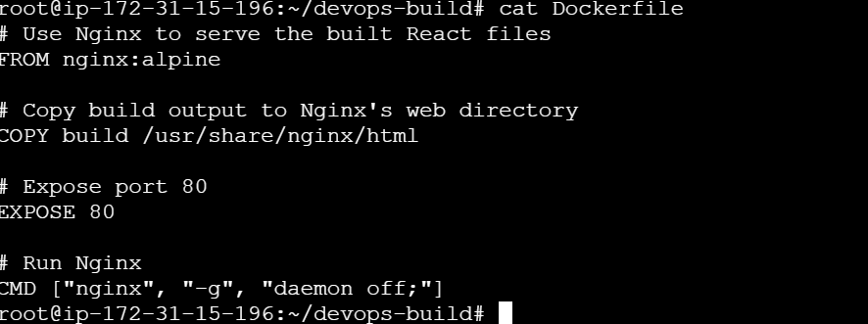
Docker images and container created
Output:
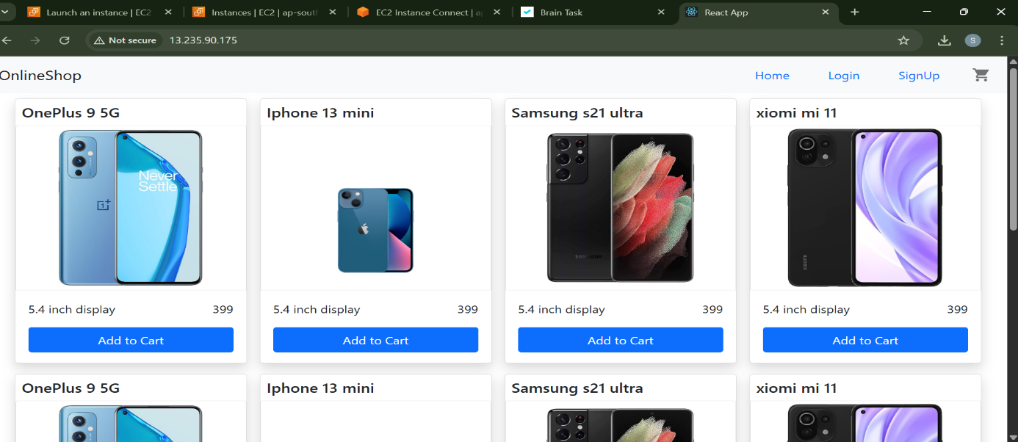
Created a docker-compose file to use the above image
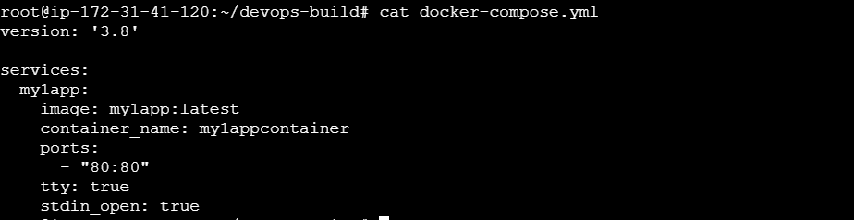
By using the command docker-compose up -d, container was created
3. Bash Scripting:
> build.sh - for building docker images, deploy.sh - for deploying the image to server
build.sh file:
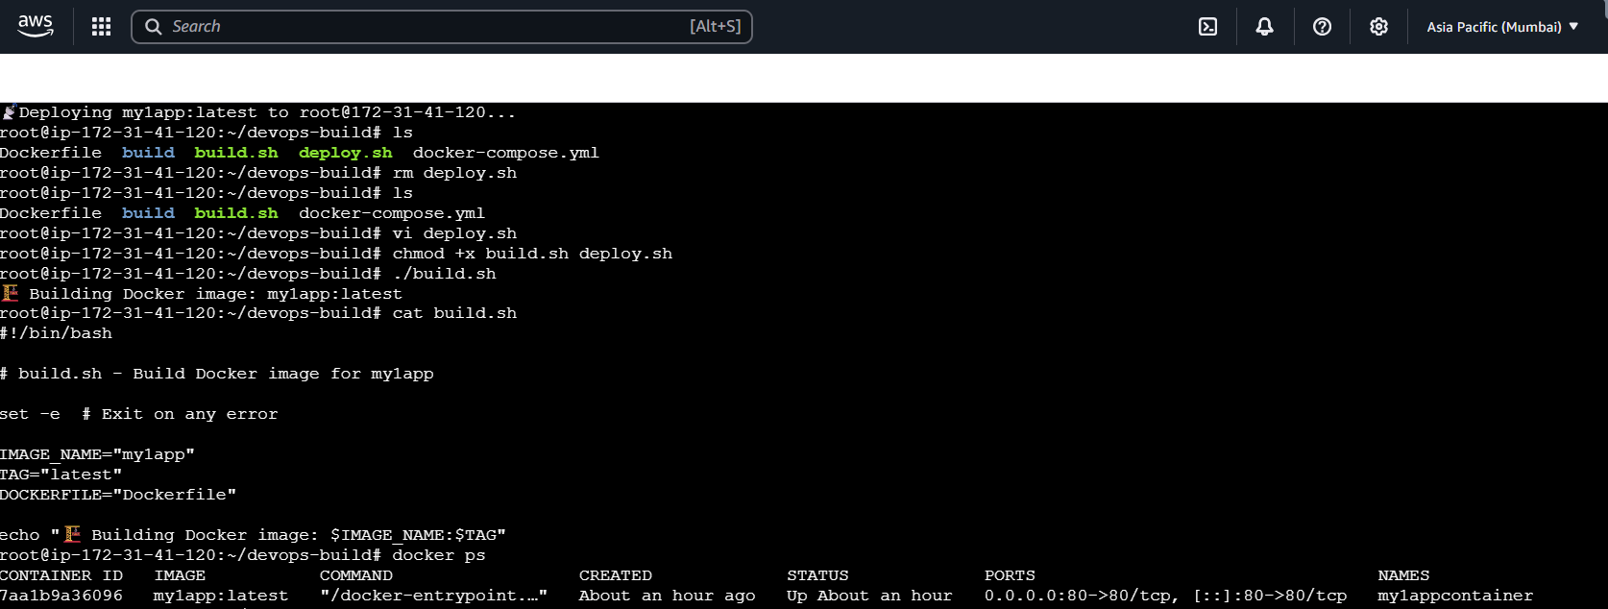
Deploy.sh file
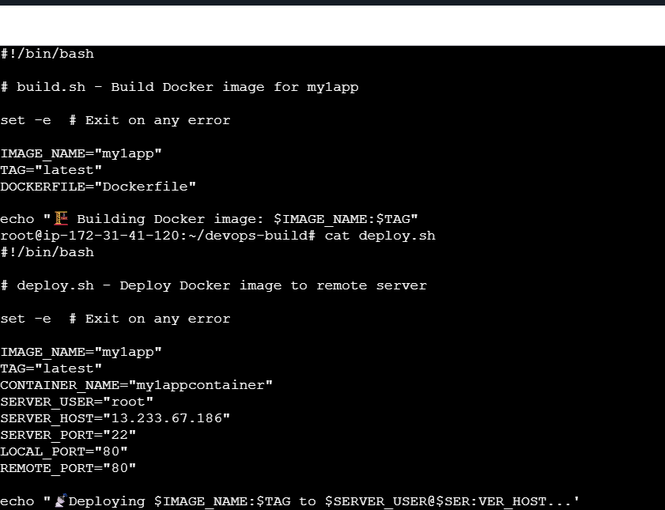
- Version Control:
Pushed the code to github to dev branch
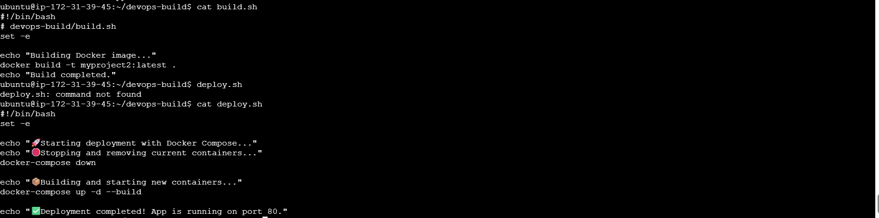
Fiiles pushed to GITHUB
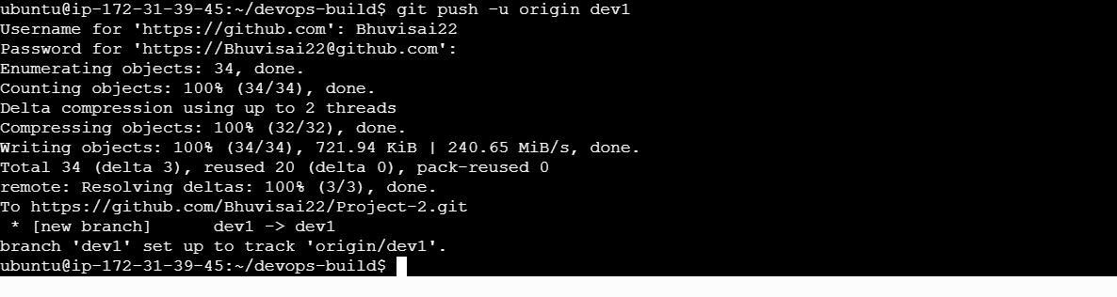
Commands used as below:

Commands:
git init
git checkout -b dev1
git add .
git commit -m "Initial commit with dockerization"
git remote add origin https://github.com/Bhuvisai22/Project-2
git push origin dev

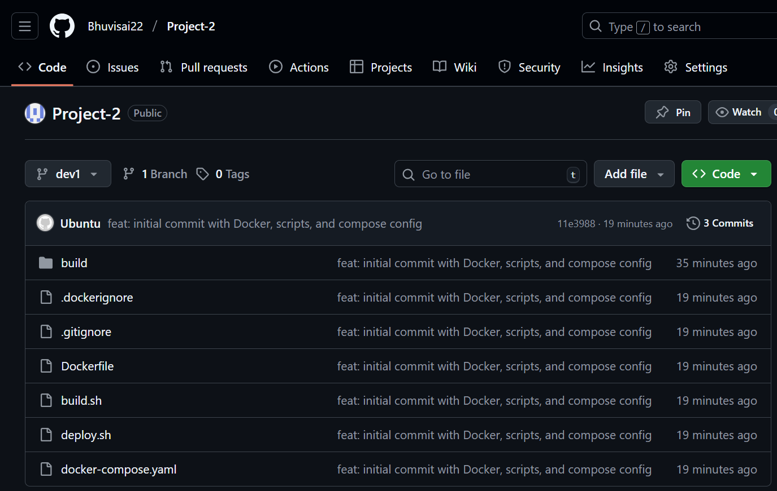
- Docker hub:
Created 2 repos "dev" and "prod" to push images.
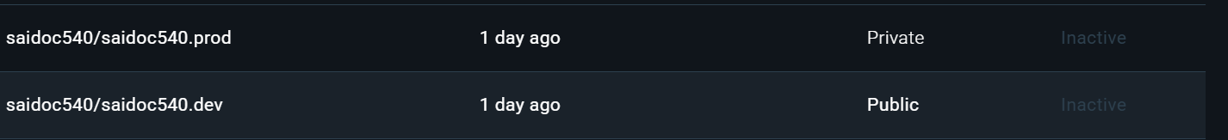
"Prod" repo is private and "dev" repo is public

- Jenkins:
Installed Jenkins 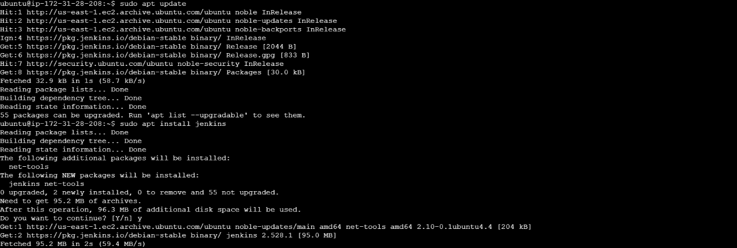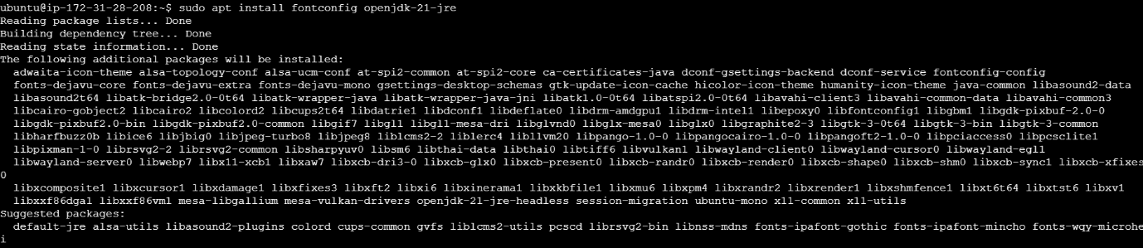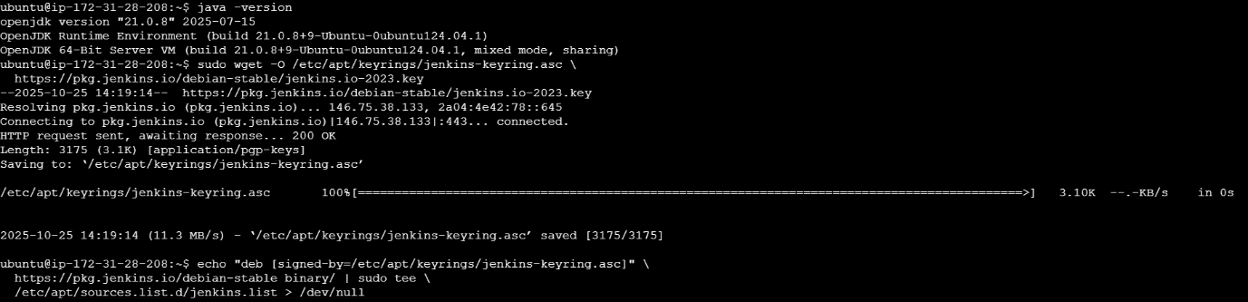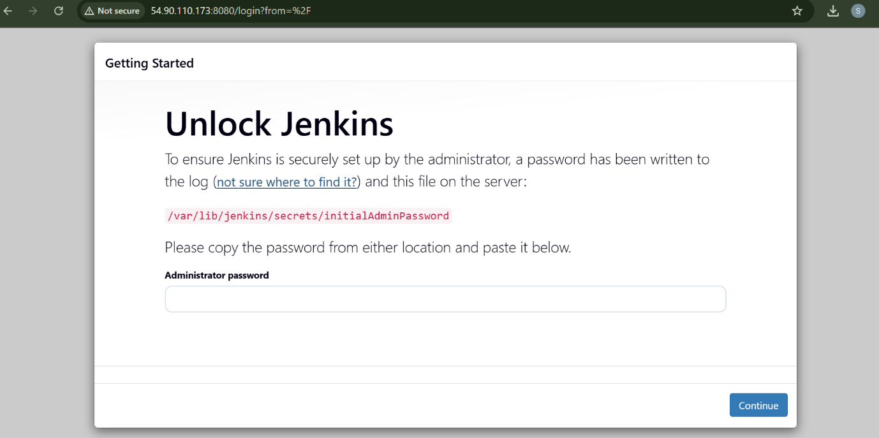
Connected jenkins to the github repo with auto build trigger from both dev & master branch
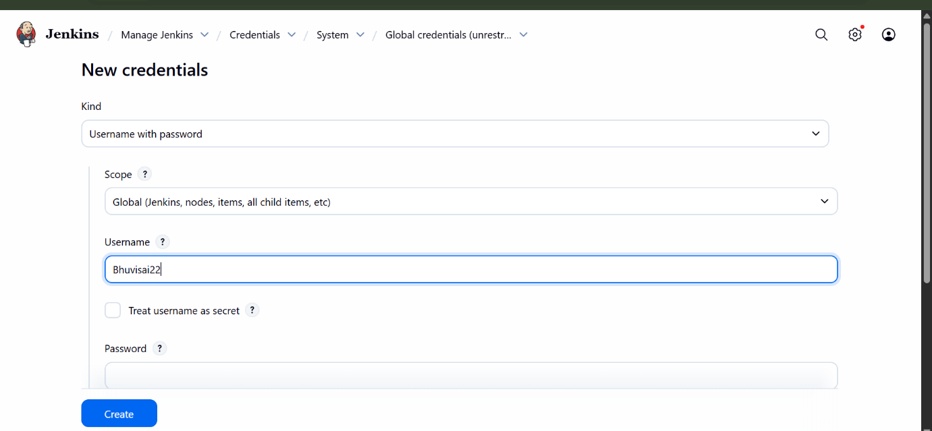

- AWS:
Launch t2.micro instance and deploy the create application.
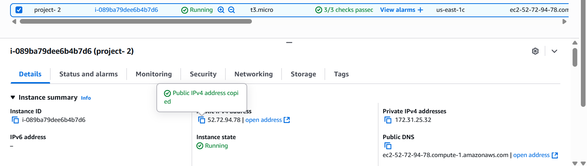
Installed Docker by using the command:
Sudo apt-get install docker.io -y
Docker-compose installation 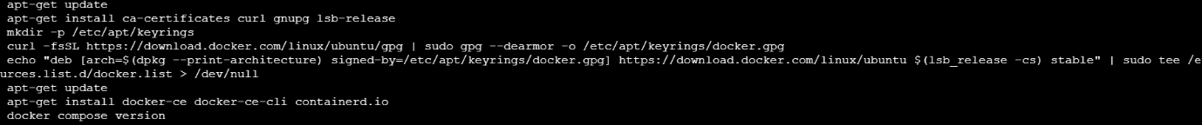
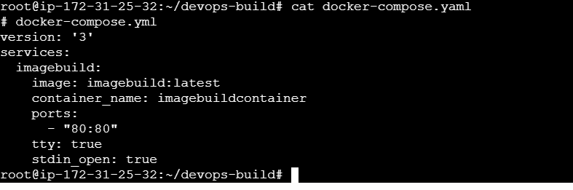
Docker images
Finally the app is available on port 80
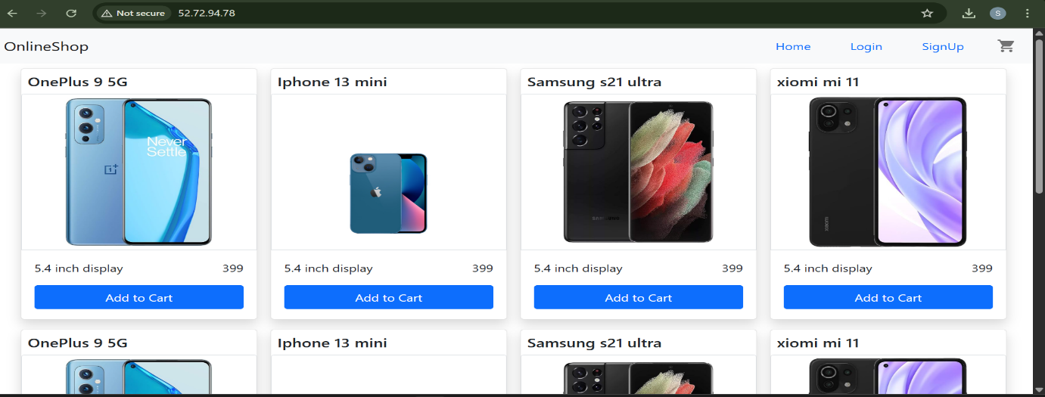
- Monitoring:
Monitored system by Uptime Kuma
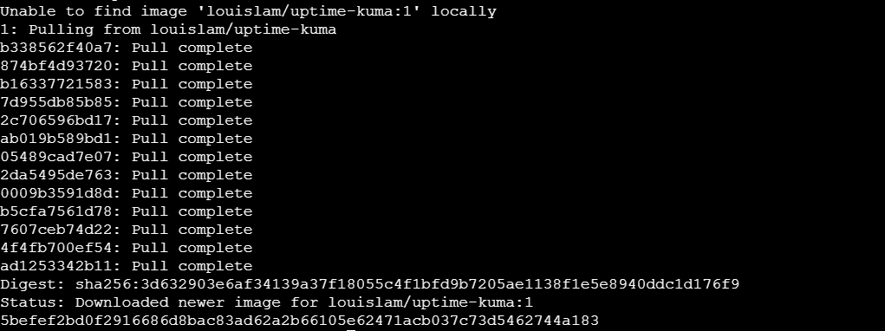
Accessed by http:// 52.72.94.78:3001
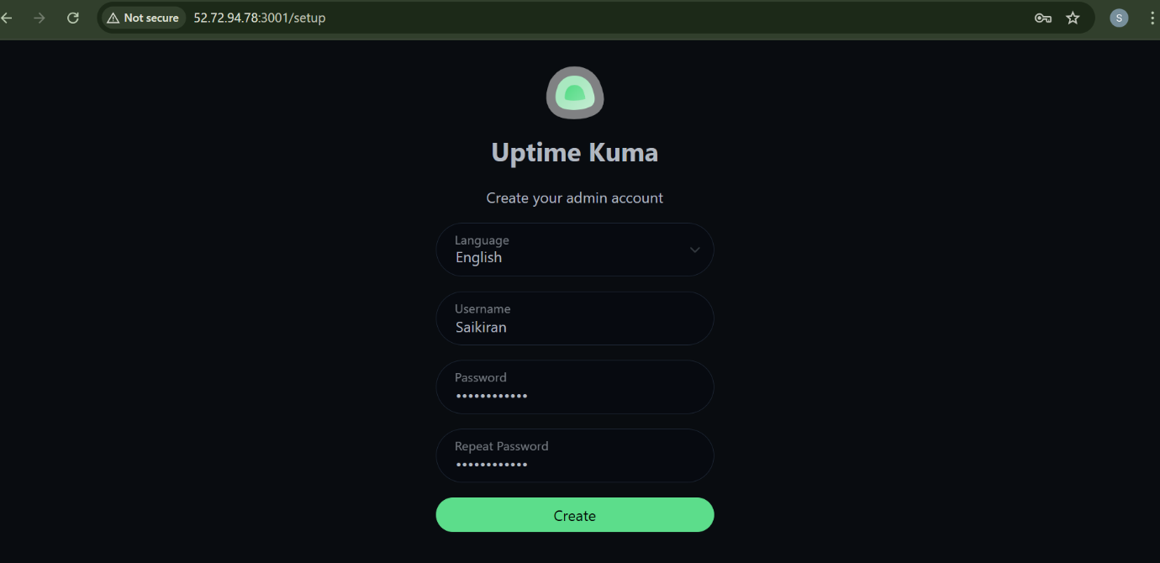
Add ed monitor for http:// 52.72.94.78:80 